Distance Learning – the Final Teaching Frontier? A Symposium with Experienced Chemical Educators in Distance Learning – A Summary Report
Lance Lund, Anoka-Ramsey Community College, Coon Rapids, MN; Kathleen Carrigan, Portland Community College, Portland, OR; Bernadette Harkness*, Delta College, University Center, MI

Abstract:
“Innovations in teaching chemistry” certainly describes the efforts applied to distance learning in undergraduate chemistry courses. This report summarizes the information shared at the distance learning symposium presented at the 195th 2YC₃ conference at Miracosta, CA in March 2012. This symposium consisted of two presentations and one panel discussion with chemical educators sharing their experiences and ideas regarding critical parameters of student success such as assessment, best practices, technology tools, and delivery methods of hands-on lab experiences. The sessions highlighted two different modalities for offering hands-on experiences for laboratory activities so that educators could decide for themselves their own preference for offering distance learning chemistry labs. The panel discussion allowed for presenters and participants to discuss further aspects and challenges of chemistry courses presented for distance learning. A full report an appendix of supplementary material can be found in the 2YC₃ archives (link).

Introduction:
Chemistry has followed other academic disciplines into the distance learning environment and with the breakneck advances in technology and new web tools, increases in online chemistry course offerings have followed. For those new to online teaching there is a sometimes steep, technological and pedagogical learning curve since the face-to-face (f2f) teaching and learning process differs greatly in an online format. The generally asynchronous nature of distance learning must provide for alternative methods of presenting materials for student engagement, communication and assessment while maintaining the checks that support academic honesty. Moreover, a laboratory component is an integral part of the learning process and the American Chemical Society (ACS) advocates for hands-on laboratory learning experiences over computer-simulated activities¹.

Online Lectures:
Learning chemistry content in an online format serves the student by allowing them to access the material at a time of their choice and to absorb it at their own pace. The greatest difference for online classes is to incorporate and maintain the communication and engagement in learning between that occurs in the f2f classroom. Traditional textbook readings and problems through online homework systems were assigned and short video recordings for difficult lecture topics and worked out solutions were also available for the students to see and hear the logic of chemistry problem solving. Camtasia and Camtasia Relay software were used to produce videos. The use of virtual office hours or synchronous online help sessions were important for students to ask questions and gain feedback on their learning, especially effective when student attendance was a requirement for a certain number of sessions. Adobe Connect and Collaborate were two synchronous web conferencing tools that were used to facilitate this activity.

Assessment:
Since most assessments were given online, including homework as well as quizzes and semester exams, one of the main concerns is the integrity of the assessment process. A suggestion to encourage academic honesty was through syllabus quizzes reflecting integrity statements by students. For example, prior to taking any online quizzes or exams, students were required to achieve 100% grade on a one-time syllabus quiz where they are obligated to type in word-for-word statements from the syllabus like “I will use only permitted materials….” etc. As well, short but doable time limits for online quizzes or tests could be used to severely restrict use of outside materials. Using creative quiz questions that would not be searchable also helped to keep students honest. For example, questions like “if chocolate with symbol Ch was similar to calcium, what would the chemical formula for chocolate nitrate be?” was used instead of conventional naming questions. Another strong recommendation was that acceptable proctors administer a paper final exam. As well, the final exam grade was compared to the average of the semester tests. If the final exam grade was ~20-30% or lower (Lance, please also check this for accuracy, I couldn’t remember the exact % values) than the average of the semester exams then the student may be required to retake the online semester exams in a proctored setting. Finally, a passing grade on the final exam was another gateway for successful completion of the course.

Hands-on Lab experience:
As part of the complete distance learning course and to follow ACS recommendations for a hands-on laboratory component¹, the presenters each gave a different means to deliver the laboratory activities. One option was an in-house developed lab kit with a core set of chemical lab equipment with other items to be purchased by the student. The other option was a commercial lab kit complete with all items. For both, the safety, affordability, and learning outcomes were considered so that the student would have as much of an equivalent learning experience as possible as in the on-campus laboratory.

Safety is a primary concern since the inherent supervision by the instructor is not available. Both presenters had mandatory safety lectures/videos and quizzes with high minimum scores as an entry for access to the lab exercises. The commercial lab kit manufacturer offers its own safety video and assumed liability of any effects from its lab kit. Other safety videos are also internet-accessible.

In-House Lab kit:
Lance Lund, with the help of chemistry stockroom personnel, presented an in-house prepared lab kit, which included a list of durable items (returnable equipment such as a digital balance, temperature probe, etc) and consumable items (chemicals used then discarded) that would be included for student purchase. The list also included general grocery store items that the student would provide. To keep costs to the student down, the kits were sold for a $75 purchase price and if returned with the durable equipment in tact, the student would receive a $50 refund. Liability was not addressed in this development but no issues were reported. Examples of laboratory exercises that could be carried out with the in-house kit are listed in the full report but represent typical introductory exercises to explore graphing, density, thermochemistry, and stoichiometry.

Commercial Lab kit:
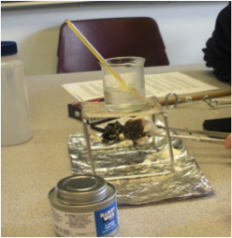
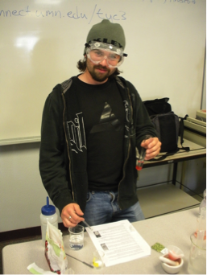
Kathy Carrigan presented her experiences of developing a hands-on lab experience in collaboration with a commercial lab kit vendor, Hands-On Labs Inc. (http://www.labpaq.com/). While at a higher cost (~$200) the custom lab kits contained all items including standard glassware and equipment. The commercial lab kit was non-returnable but the vendor also assumed liability of its product and has reported no safety issues with its product. The kit activities demonstrated how density/measurement, synthesis of esthers, caloric content of food and the extraction of DNA could be carried out by a student with a home lab kit. A schedule of lab exercises for the GOB and introductory courses is found in the Appendix of the full report.
c) The DNA extracted from strawberries
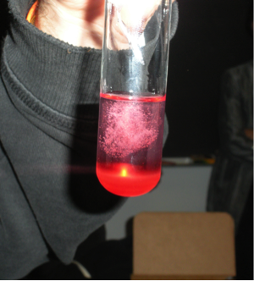
b) A student helper, Russell Kellog, carried out the DNA extraction.
a) Setup for measuring the caloric content of a marshmallow

Successful Practices for Distance Learning Lab Exercises
Suggestions included: weekly lab assignments with generous but firm due dates, allowing 1 or 2 lab assignments to be dropped, giving videos as pre-lab lectures or setting up instructional online sessions to promote communication and answer safety questions, encourage collaboration among students and require unique lab reports that included photo or video evidence (with date stamps) of student work.

Transitioning from On-campus to On-line: Tips for success
- Start early (~6-9 months) and have entire course materials prepared before start of the class. Research LMS features or software for online delivery, video technology or resources, and attend distance learning workshops for new teaching/learning techniques.
- Establish support for instructor from mentors, instructional designers, distance learning support personnel and online resources. Use student beta testers for feedback and modifications.
Have | Factor | Want
4.50 g HCl | 1 mol HCl | = mol HCl
 | 36.46 g HCl
- Establish support for students so that they know where to seek help from distance learning support personnel and online resources.
- Allow for extra student response time and establish clear guidelines including response times for feedback. Use synchronous online help sessions for problem solving and immediate feedback activities.
- Use tables to show unit cancellations for dimensional analysis solutions as shown:

Acknowledgements:
The authors wish to acknowledge and thank the ACS Office of Two-Year Colleges for travel funds to support this symposium. In addition, many thanks go to the co-panelists Carmela Byrnes and Jim Julius from MiraCosta Community College for their participation in the panel discussion as well as the 2YC3 organizers from Miracosta Community College. Lastly but not least the help of the student volunteers particularly Russell Kellogg, for the hands-on demonstration is gratefully acknowledged.

References:
1. ACS position statement: Importance of Hands-On Laboratory Activities
http://portal.acs.org/portal/acs/corg/content?_nfpb=true&_pageLabel=PP_SUPERARTICLE&node_id=2223&use_sec=false&sec_url_var=region1&__uuid=eba3b77e-5149-44f4-bac2-bfcc4f69b7d4) (accessed June 2012)

